SDEV1201 — Day 9 Homework
Funky Flowers — Datatypes, NULL, Create Table, Drop Table, Indexes
Do this on your own, using today's in-class Monthly Desk work as your model.
Same skills as class, new dataset. No Primary Keys, Foreign Keys, or other constraints yet — just columns, datatypes, Not Null / Null, and indexes. If you get stuck, re-open today's Monthly Desk packet — every pattern you need is already in there.

The ERD

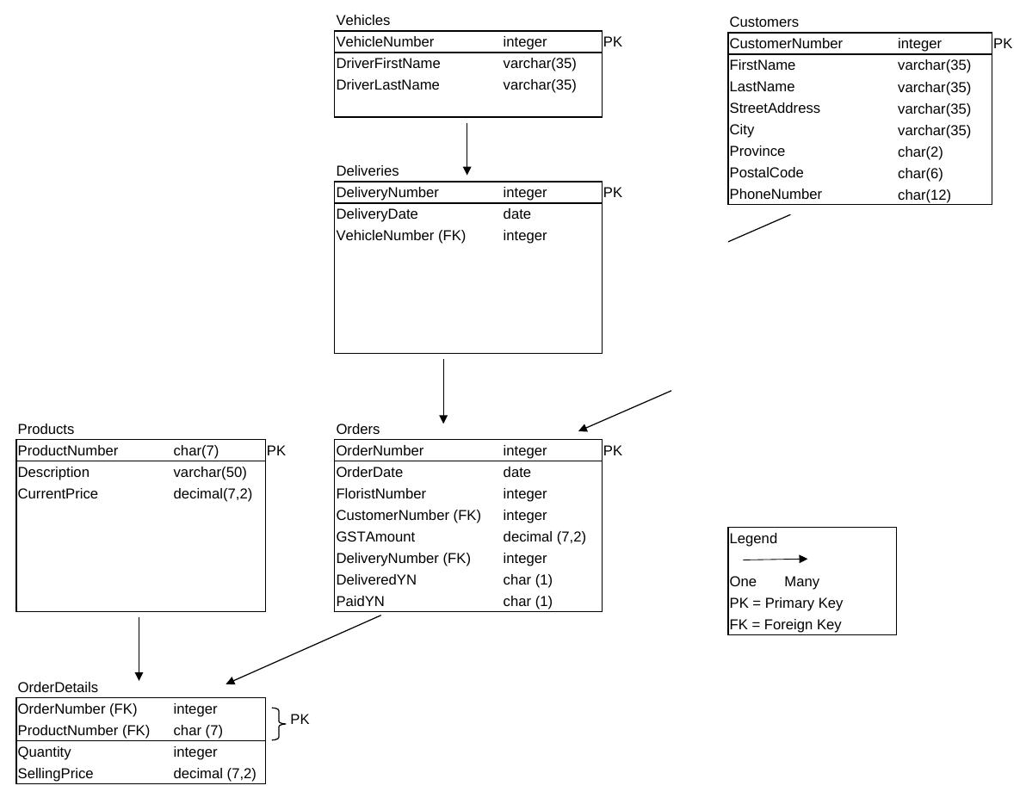
Ignore the connecting lines between boxes for now — those become Foreign Keys next class. Today, treat each box as its own independent table.

Part 1 — Create every table

Create all six tables below. For each column, pick a sensible datatype and decide Not Null or Null using the same test as class: "could a real row legitimately not have this value yet?" If yes, it's Null.
1. Vehicles — VehicleNumber, DriverFirstName, DriverLastName.
2. Products — ProductNumber (7-character code), Description, CurrentPrice.
3. Customers — CustomerNumber, FirstName, LastName, StreetAddress, City, Province (2-letter code), PostalCode (6 characters), PhoneNumber (12 characters — think about whether every customer necessarily has one on file).
4. Deliveries — DeliveryNumber, DeliveryDate, VehicleNumber.
5. Orders — OrderNumber, OrderDate, FloristNumber, CustomerNumber, GSTAmount, DeliveryNumber, DeliveredYN (1 character), PaidYN (1 character). Think carefully about which of these an order might not have a value for the moment it's placed.
6. OrderDetails — OrderNumber, ProductNumber (7-character code), Quantity, SellingPrice.
Start every Create Table with a Drop Table If Exists <name>; line, exactly like in class — that way you can re-run your script as many times as you like while you're testing it.

Part 2 — Indexes

Create an index on Customers(LastName) and on Orders(OrderDate) — think about why each one is a reasonable column to search or sort by often. Then drop one of the two, just to practice the syntax.

Save your finished script — next class we come back to these same six tables and add Primary Keys, Foreign Keys, and a composite key on OrderDetails.

